GUIDEBEE
Map Local API Developer Guide
On Java ME platform



James Shen
www.guidebee.biz
Guidebee Biz.

ISSUE/AMENDMENT STATUS

Issue | Date | Description | Author
1.0 | 05th Mar 2008 | First Version | James Shen jing.shen@guidebee.biz

TABLE OF CONTENTS
ISSUE/AMENDMENT STATUS 2
1.0 Overview of Guidebee Map Local Java ME API 4
1.1 Package gis 5
1.2 Package gis.geometry 6
1.3 Package gis.Local 7
2.0 Sample Map Data 8
2.1 Raster Maps 10
2.2 Vector Maps 11
3.0 Map Basics 12
3.1 The "Hello, World" of LocalMap 12
3.1.1 Define a GeoSet instance to load Map geoset information 14
3.1.2 Define the LocalMap Object. 15
3.1.3 Set LocalMap’s Geoset property 15
3.1.4 Set LocalMap’s projection property 15
3.1.5 Open the localMap before call any other methods 15
3.1.6 Set LocalMap’s other properties if you like 15
3.1.7 Draw the map image 15
3.1.8 Close the localMap after using it 16
4.0 Map Operation 17
4.1 Map Layer 17
4.2 Zoom In/Zoom Out 19
4.3 Map Pan 21
4.4 Zoom Layering 24
5.0 Local Map query 25
5.1 General query In Data Table 25
5.2 Spatial query in Geodatabase 28
6.0 Other features 29
6.1 Drawing quality 29
6.2 Access map file from Memory card 29
7.0 Licence 33

- Overview of Guidebee Map Local Java ME API
Guidebee Map Local Java ME API implements a mobile GIS engine for J2ME platform (CLDC/MIDP). It provides a subset of MapInfo functionalities.
Guidebee Map Local Java ME API uses maps converted from MapInfo tables.
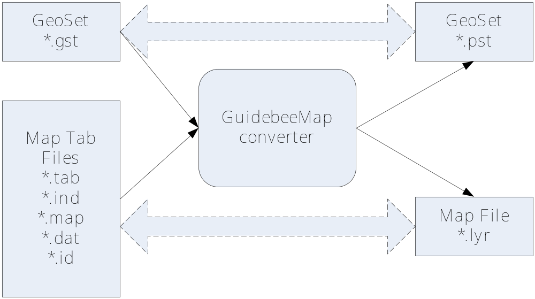
With Guidebee Map Converter, MapInfo‘s Geoset file (*.gst) is converted to Guidebee GeoSet file (*.pst) and MapInfo Map Data (*.tab,*.ind,*.map,*.data,*.id or *.mif, *.mid) are converted into one Guidebee map layer file (*.lyr). Normally the converted map files have less disk space (about 30%-40% of originally MapInfo tables).
Note: currently Guidebee Map converter only support converting MapInfo data in (Latitude/Longutide) format.
MapInfo defines 12 different Map Object type including “None”, for simplicity, some of map object type are maping to it’s general map object type, for example, LINE is mapping to PLINE after conversion.
Here’s is the mapping table.

MapInfo Type | Guidebee Map Object Type | Map Object Class
NONE | NONE | MapNoneObject
POINT | POINT | MapPoint
LINE | PLINE | MapPline
PLINE | PLINE | MapPline
REGION | REGION | MapRegion
ARC | PLINE | MapPline
TEXT | TEXT | MapText
RECT | REGION | MapRegion
ROUNDRECT | REGION | MapRegion
ELLIPSE | REGION | MapRegion
MULTIPOINT | MULTIPONT | MapMultiPoint
PLINE MULTIPLE | MULTIPLINE | MapMultiPline
REGION MULTIPLE | MULTIREGION | MapRegion
COLLECTION | COLLECTION | MapCollection

With Guidebee Map (Local) Java ME API, a MIDlet can query local geodatabase, draw map image, find an address and get a direction.
It includes following 3 sub packages:
- biz.guidebee.gis
- biz.guidebee.gis.geometry
- biz.guidebee.gis.local
  - Package gis
Package gis define some common Map Objects:
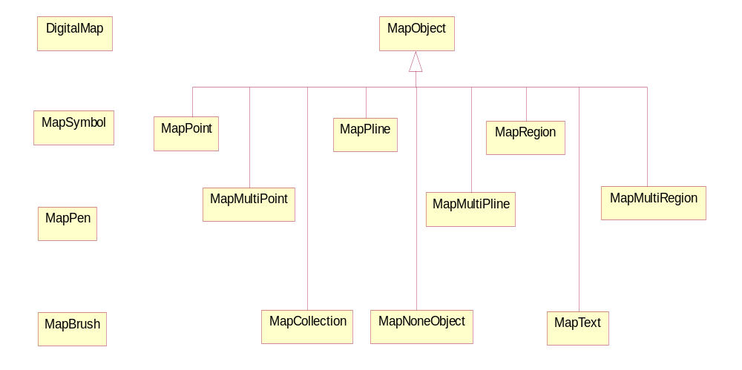
DigtialMap | DigitalMap is the base class for LocalMap and ServerMap.
MapObject | Base class of all map objects.
MapSymbol | Map symbol used to display a point.
MapPen | Map pen used to draw a map object.
MapBrush | Map brush used to paint a map object.
MapPoint | Class MapPoint stands for a point map object.
MapPline | Class MapPline stands for a map pline object.
MapRegion | Class MapRegion stands for a map region object.
MapMultiPoint | Class MapMultiPoint stands for map points’ collection.
MapMultiPline | Class MapMultiPline stands for map plines’ collection.
MapMultiRegion | Class MapMultiRegion stands for map regions' collection.
MapCollection | Class MapCollection stands for a collection of map objects.
MapNoneObject | Class MapNoneObject stands for a map object without geo info.
MapText | Class MapText stands for a text map object.

  - Package gis.geometry
This package defines geographical geometry objects, like polygon, point, polyline etc.

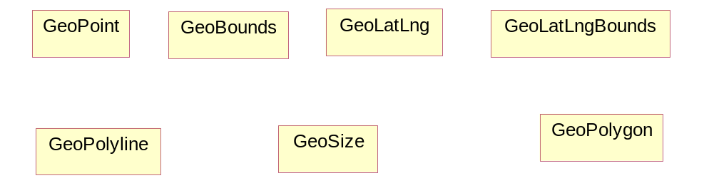
GeoBounds | GeoBounds is a rectangular area of the map in pixel coordinates
GeoLatLng | GeoLatLng is a point in geographical coordinate’s longitude and latitude.
GeoLatLngBounds | GeoLatLng is a bound in geographical coordinate’s longitude and latitude.
GeoPoint | A point representing a location in (x,y) coordinate space, specified in integer precision.
GeoPolygon | Polygon on map.
GeoPolyline | Polyline on map.
GeoSize | The GeoSize class encapsulates the width and height of a component (in integer precision) in a single object.

  - Package gis.Local
The Local package defines object used to query from local geo database.

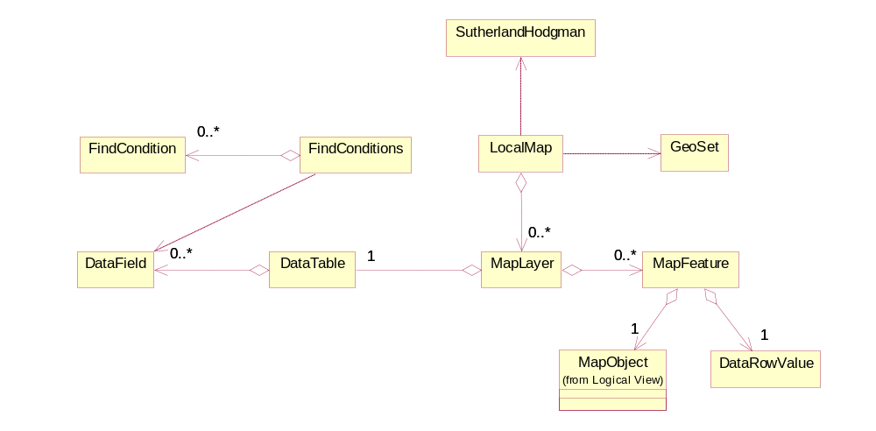
SutherlandHodgman | Implements Sutherland-Hodgman clip algorithem.
LocalMap | LocalMap is the basic building blocks for Guidebee local map. Each map is consists of multiple map Layers.
GeoSet | The Geoset object is built off the Map object and allows you to define a geoset. A Geoset is a collection of map layers and their settings.
MapLayer | MapLayer defines a map layer.Computer maps are organized into layers.
MapFeature | MapFeature defines a map feature in a map layer.
DataTable | Defines one tabular database table
DataField | Defines a filed of a database table.
DataRowValue | Defines a row of a database table.
FindCondition | Defines a find condition when seach for records.
FindConditions | Defines a find condition collection when seach for records.
- Sample Map Data
In this developer guide, we’ll use map data of Mawson Lakes, South Australia, following is the google map clip of such area.
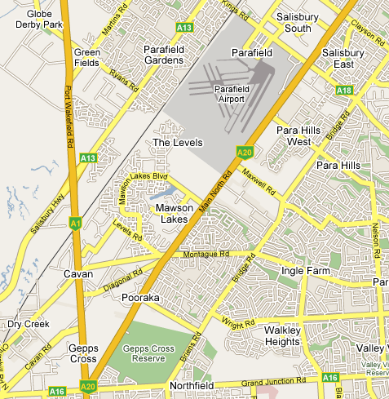
The MapInfo display such area as following
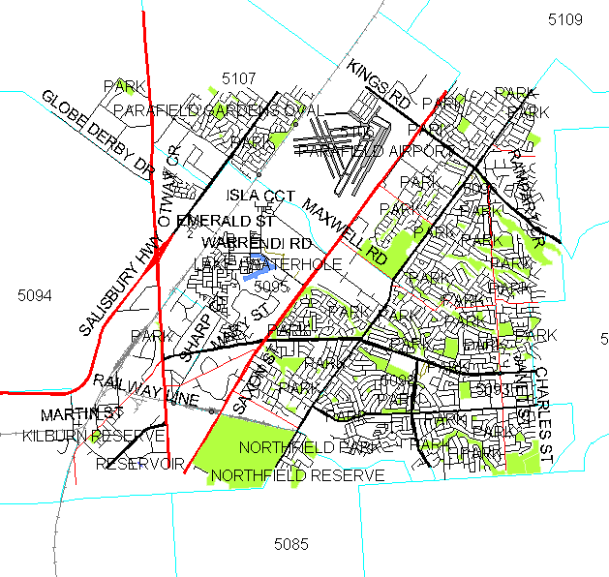
The original map data contains 7 map layers:
Raiway Station | 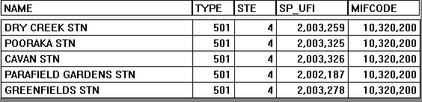 | 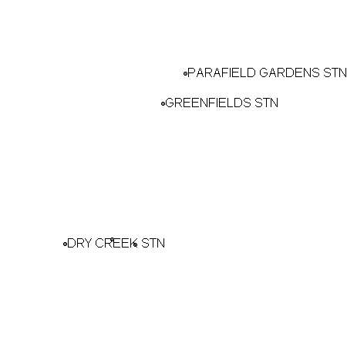
Streets | 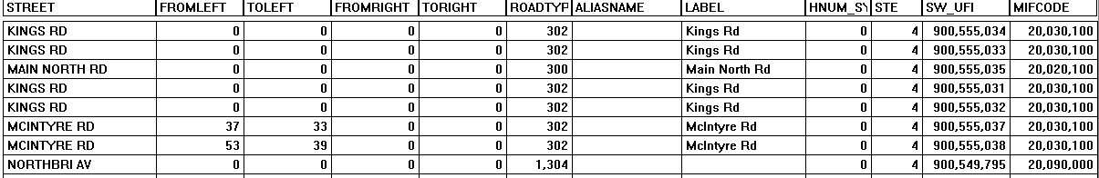 | 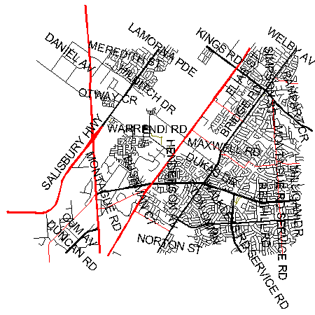
Railway | 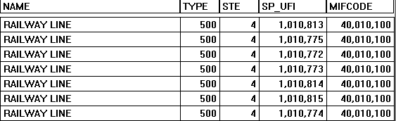 | 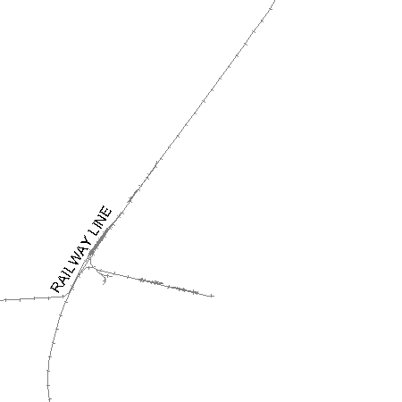
Park | 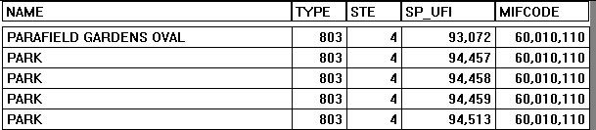 | 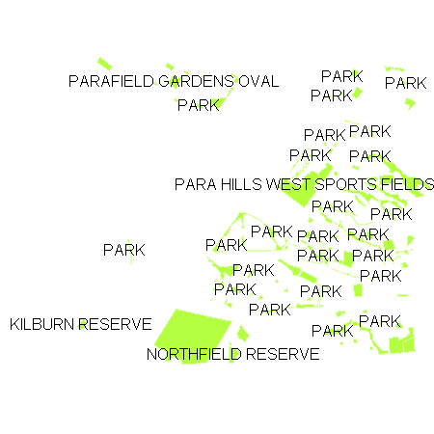
Water body | 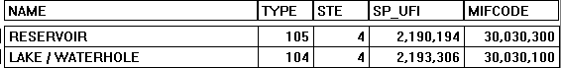 | 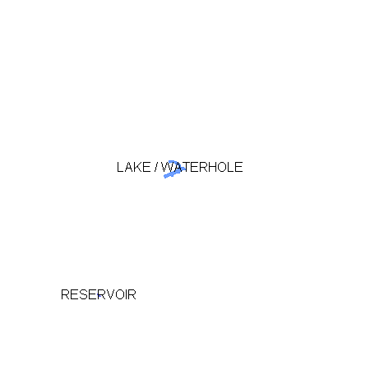
Airport |  | 
Post code  region | 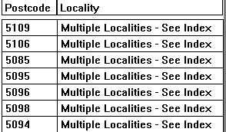 | 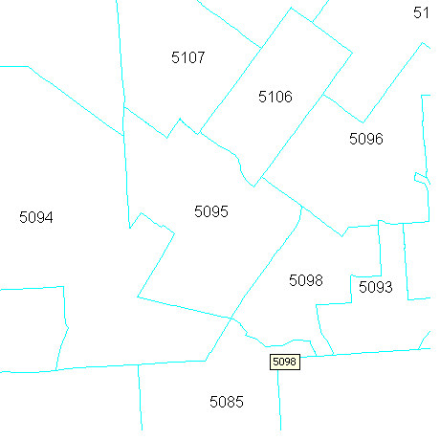
We have already said that computer maps are a collection of layers. Each map table that contains graphic objects can be displayed as a layer in a map window. For example, you can a table of streets, and a table of county boundaries.
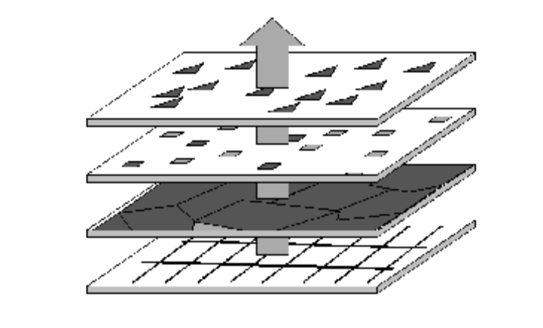
Think of these layers as transparencies where each layer contains a different part of the map. The layers are stacked one on top of the other and allow you to see all aspects of the map at the same time. For example, one layer may contain country boundaries, a second layer may have symbols that represent capitals, and a third layer might consist of highways. Laying these transparencies one on top of the other builds a complete map.
So laying above 7 map layers of Mawson Lakes, South Australia. We get the final map contains railway station, streets, airport, parks etc.
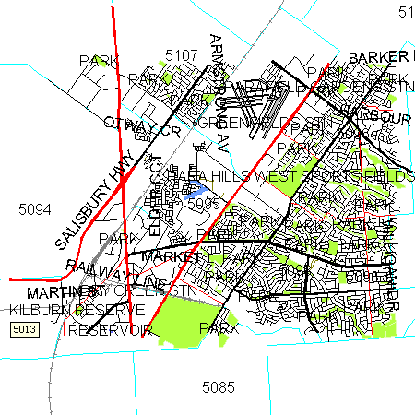
Unlike google map, which is of raster map type, Guidebee local map API provides vector map support as MapInfo does.
There are two basic types of digital maps, and it's important to understand the difference between the two. The first is Raster maps, and the second is Vector maps.
  - Raster Maps
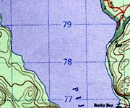
Raster maps are based on conventional image files. These maps are, quite simply, scans of a paper maps that are saved in an image format like .gif or .png. They are generated by running the original topo maps through a large scanner and saving the copy as a digital file. The advantage of this type of map? They are an exact duplicate of the original paper topo map, with all of the detail that we're used to seeing. The disadvantage? Being an image file (just like a digital photo), they don't scale well. If you try to "zoom in" on the image, it quickly becomes pixellated and fuzzy. If you "zoom out" to any significant degree, the text and details on the map quickly becomes unreadable.
Because raster maps retain all of the detail of the map upon which they are based, they are a fairly large image file.
  - Vector Maps
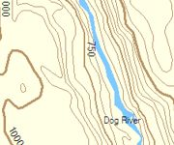
Vector maps are not an image file like raster maps. Vector maps consist of a text file with coordinates describing the various points and curves on a map. When they are loaded into a mapping program, that data is used to generate a map image.
As you would expect, the advantages and disadvantages of this map type are the exact opposite of those of raster maps. Because the image is generated "on the fly" from the data, these maps scale up and down with no loss of clarity. You can zoom out to see an entire river system, or zoom in to see specific areas and retain the readability of the map in both.
The only disadvantage to vector maps might be the diminished level of detail. Although there is no reason that the vector data could contain all of the detail of an original topo, these maps almost always have less detail.

Generally speaking, Guidebee Server Map API provides Raster Map support, while Guidebee Local Map API provides Vector Map support. But they are not conflict, there’s way that you can combine the raster and vector map support in one application with Guidebee Map API.

- Map Basics
The fundamental element in any Guidebee Maps (Local) API application is the "LocalMap" itself. This section discusses usage of the fundamental LocalMap object and the basics of map operations
  - The "Hello, World" of LocalMap
The following example displays a map at Mawson Lakes, South Australia.

//--------------------------------- PACKAGE ------------------------------------
package biz.guidebee.gis.local.example;

//--------------------------------- IMPORTS ------------------------------------
import java.io.*;
import javax.microedition.midlet.*;
import javax.microedition.lcdui.*;

import biz.guidebee.drawing.*;
import biz.guidebee.geometry.*;
import biz.guidebee.gis.local.*;
import biz.guidebee.gis.geometry.*;

import biz.guidebee.licence.*;

public class HelloWorld extends MapLocalMIDlet {
/**
* The display object associated with the MIDlet.
*/
private Display display;

/**
* The Canvas object.
*/
private Canvas2D canvas;

/**
* The graphics object.
*/
private Graphics2D graphics2D;

public HelloWorld() throws InvalidLicenceException {

super();
display = Display.getDisplay(this);
canvas = new Canvas2D(display);
graphics2D = canvas.getGraphics();
}

public void startApp() throws MIDletStateChangeException {
display.setCurrent(canvas);
//Clear the canvas with white color.
graphics2D.clear(Color.WHITE);
AffineTransform matrix=new AffineTransform();
graphics2D.setAffineTransform(matrix);
LocalMap localMap=null;
try{
String geoSetFile="/MawsonLakes.pst";
InputStream is=this.getClass().getResourceAsStream(geoSetFile);
if(is!=null){
int fileLength=is.available();
byte []buffer=new byte[fileLength];
is.read(buffer);
ByteArrayInputStream bais=new ByteArrayInputStream(buffer);
DataInputStream reader=new DataInputStream(bais);
GeoSet geoSet=new GeoSet(this,reader);
is.close();
GeoBounds bounds=new
GeoBounds(0,0,canvas.getWidth(),canvas.getHeight());
localMap=new LocalMap(bounds);
localMap.setGeoSet(geoSet);
localMap.open();
localMap.mapProjection=LocalMap.MAP_PROJECTION_WGS84;
localMap.fontEx=FontEx.getSystemFont();
localMap.setZoom(13) ;
Image image=localMap.getMapImage();
graphics2D.drawImage(image,0,0, ,Graphics.TOP|Graphics.LEFT);
localMap.close();

}

} catch(Exception e) {
System.out.println(e.getMessage());
}

graphics2D.invalidate();
}

public void pauseApp() {
}

public void destroyApp(boolean unconditional)
throws MIDletStateChangeException {
canvas.flush();
canvas = null;
System.gc();
}
}

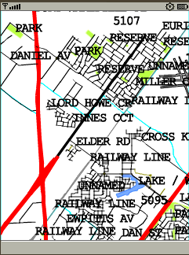
In this simple example, there are several things to note:
- Define a GeoSet instance to load Map geoset information.
- Define a LocalMap instance to create a new “Map” object.
- Set LocalMap’s Geoset property.
- Set LocalMap’s projection property.
- Open the localMap before call any other methods.
- Set LocalMap’s other properties if you like.
- Draw the map image.
- Close the localMap after using it.
    - Define a GeoSet instance to load Map geoset information
There are several ways you can load map data into LocalMap object, the easiest way is using GesSet class. GeoSet read from .pst (Geoset file) which stores all the Map layers and their setting.
Geoset has two overloaded constructor, one take a string as parameter, which is the path name. For cases those map file are stored in memory card and you want to make use of JSR75 fileconnection API to access these files.
For small map file, you can also put those map file as resources and load them into main memory.
GeoSet’s another constructor takes DataInputStream as the parameter. You can point this DataInputStream to the main memory like the example does.
Put map data in the main memoery normally is much faster than directly access from memory card. But this will consume a lot main memeory; it’s only usefully when the loaded map file is not that big.
The total size of Mawson Lakes, South Australia is about 900K; we’ll load them into main memory.
In you want to run it on the emulator, make sure you have enough memory for the device. You can Change the Storage in the Preferences tab.
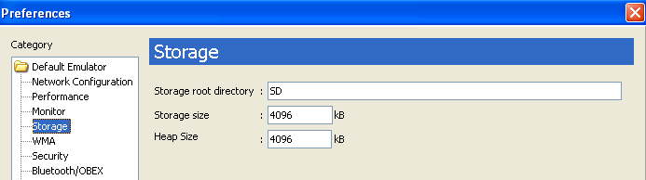

String geoSetFile="/MawsonLakes.pst";
InputStream is=this.getClass().getResourceAsStream(geoSetFile);
int fileLength=is.available();
byte []buffer=new byte[fileLength];
is.read(buffer);
ByteArrayInputStream bais=new ByteArrayInputStream(buffer);
DataInputStream reader=new DataInputStream(bais);
GeoSet geoSet=new GeoSet(this,reader);
    - Define the LocalMap Object.
LocalMap’s constructor is defined as following:
public LocalMap(GeoBounds bounds)
throws biz.guidebee.licence.InvalidLicenceException
bounds defines defines the width and height of the map ,normally it’s the width and height of the canvas.

GeoBounds bounds=new GeoBounds(0,0,canvas.getWidth(),canvas.getHeight());
localMap=new LocalMap(bounds);

    - Set LocalMap’s Geoset property
After we define the Geoset instance, we can associate it with the LocalMap instance.
localMap.setGeoSet(geoSet);
    - Set LocalMap’s projection property
Currently LocalMap support two Map project methods.
One is MAP_PROJECTION_SIMPLE, which is a simple linear mapping from (latitude, longitude) to screen coordinates (y, x).
Normally it’s faster than MAP_PROJECTION_WGS84.
MAP_PROJECTION_WGS84 use WGS84 projection, if you want to combine LocalMap with some other map format uses WGS84, this is the choice. It uses same map projection as Yahoo Map, Microsoft Map, and Google map.
    - Open the localMap before call any other methods
Before call any other methods of LocalMap, open shall be the first method. Open initialize all MapLayer objects within the LocalMap.
localMap.open();
    - Set LocalMap’s other properties if you like
You can also set LocalMap’s font type, zoom level after map is open.
localMap.fontEx=FontEx.getSystemFont();
localMap.setZoom(13) ;

    - Draw the map image
LocalMap’s getImage method return a Image object, you can use any Graphics object to draw it on screen.
Image image=localMap.getMapImage();
graphics2D.drawImage(image,0,0, ,Graphics.TOP|Graphics.LEFT);

    - Close the localMap after using it
Finally we should close map after using it. The close method actually close all opened input streams and releases the resources.
localMap.close();
- Map Operation
LocalMap has methods to zoom / pan the map and manage Map layers.
  - Map Layer
The Map Layer object represents vector mapping data in the form of a collection of map features having a predominant feature type, such as regions, lines or points. Typically, a Layer object corresponds to the geographic objects from one MapInfo table. Each of the Layer objects in a Layer collection behaves independently of the others. Their styles may be changed, their zoom layering altered, etc., on an individual basis, without affecting any of the other layers.
Besides using Geoset, we can also manully add or remove Map Layers from the LocalMap object.
The follow example only loads the “Airport” and “Post Code Area” layer into LoalMap.

//--------------------------------- PACKAGE ------------------------------------
package biz.guidebee.gis.local.example;

//--------------------------------- IMPORTS ------------------------------------
import java.io.*;
import javax.microedition.midlet.*;
import javax.microedition.lcdui.*;

import biz.guidebee.drawing.*;
import biz.guidebee.geometry.*;
import biz.guidebee.gis.local.*;
import biz.guidebee.gis.geometry.*;

import biz.guidebee.licence.*;

public class LayerDemo extends MapLocalMIDlet {
/**
* The display object associated with the MIDlet.
*/
private Display display;

/**
* The Canvas object.
*/
private Canvas2D canvas;

/**
* The graphics object.
*/
private Graphics2D graphics2D;

public LayerDemo() throws InvalidLicenceException {

super();
display = Display.getDisplay(this);
canvas = new Canvas2D(display);
graphics2D = canvas.getGraphics();
}

public void startApp() throws MIDletStateChangeException {
display.setCurrent(canvas);
//Clear the canvas with white color.
graphics2D.clear(Color.WHITE);
AffineTransform matrix=new AffineTransform();
graphics2D.setAffineTransform(matrix);
LocalMap localMap=null;
try{
GeoBounds bounds=new GeoBounds(0,0,canvas.getWidth(),canvas.getHeight());
localMap=new LocalMap(bounds);

String []mapLayerNames=new String[]{
"/AUS_AIR.lyr",
"/AUST05_PC.lyr"
};
for(int i=0;i<mapLayerNames.length;i++){
String mapLayerName=mapLayerNames[i];
InputStream is=this.getClass().getResourceAsStream(mapLayerName);
int fileLength=is.available();
byte []buffer=new byte[fileLength];
is.read(buffer);
ByteArrayInputStream bais=new ByteArrayInputStream(buffer);
DataInputStream reader=new DataInputStream(bais);
MapLayer mapLayer=new MapLayer(reader);
localMap.addLayer(mapLayer);
is.close();
}

localMap.fontEx=FontEx.getSystemFont();
localMap.open();
localMap.mapProjection=LocalMap.MAP_PROJECTION_WGS84;
localMap.setZoom(12);
Image image=localMap.getMapImage();
graphics2D.drawImage(image,0,0,Graphics.TOP|Graphics.LEFT);
localMap.close();

} catch(Exception e) {
System.out.println(e.getMessage());
}

graphics2D.invalidate();
}

public void pauseApp() {
}

public void destroyApp(boolean unconditional)
throws MIDletStateChangeException {
canvas.flush();
canvas = null;
System.gc();
}
}

LocalMap has method addLayer, insertLayer, removeLayer, removeAllLayers, and moveLayer to manipulate Map Layers.
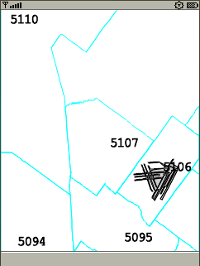
  - Zoom In/Zoom Out
The following examples display how to zoom in/Zoom out map.

//--------------------------------- PACKAGE ------------------------------------
package biz.guidebee.gis.local.example;

//--------------------------------- IMPORTS ------------------------------------
import java.io.*;
import javax.microedition.midlet.*;
import javax.microedition.lcdui.*;

import biz.guidebee.drawing.*;
import biz.guidebee.geometry.*;
import biz.guidebee.gis.local.*;
import biz.guidebee.gis.geometry.*;

import biz.guidebee.licence.*;

class MapZoomCanvas extends Canvas2D implements CommandListener{
public LocalMap map=null;
private Command cmdZoomIn=new Command("ZoomIn",Command.ITEM,1);
private Command cmdZoomOut=new Command("ZoomOut",Command.ITEM,1);

MapZoomCanvas(Display display) throws InvalidLicenceException{
super(display);

addCommand(cmdZoomIn);
addCommand(cmdZoomOut);
setCommandListener(this);
}

protected void drawMapImage(){
try{
Graphics2D graphics2D=this.getGraphics();
graphics2D.clear(Color.WHITE);
Image image=map.getMapImage();
graphics2D.drawImage(image,0,0,Graphics.TOP|Graphics.LEFT);
graphics2D.invalidate();
} catch(IOException e){
//ingore
}
}

public void commandAction(Command command, Displayable displayable) {
// for Tool command
if (command == cmdZoomIn) {
map.zoomIn();
drawMapImage();

}
if (command == cmdZoomOut) {
map.zoomOut();
drawMapImage();
}
}
}

public class MapZoom extends MapLocalMIDlet {
/**
* The display object associated with the MIDlet.
*/
private Display display;

/**
* The Canvas object.
*/
private MapZoomCanvas canvas;

/**
* The graphics object.
*/
private Graphics2D graphics2D;

private LocalMap localMap=null;

public MapZoom() throws InvalidLicenceException {
super();
display = Display.getDisplay(this);
canvas = new MapZoomCanvas(display);
GeoBounds bounds=new GeoBounds(0,0,canvas.getWidth(),
canvas.getHeight());
localMap=new LocalMap(bounds);
canvas.map=localMap;
graphics2D = canvas.getGraphics();
}

public void startApp() throws MIDletStateChangeException {
display.setCurrent(canvas);
//Clear the canvas with white color.
graphics2D.clear(Color.WHITE);
AffineTransform matrix=new AffineTransform();
graphics2D.setAffineTransform(matrix);

try{
String geoSetFile="/MawsonLakes.pst";
InputStream is=this.getClass().getResourceAsStream(geoSetFile);
if(is!=null){
int fileLength=is.available();
byte []buffer=new byte[fileLength];
is.read(buffer);
ByteArrayInputStream bais=new ByteArrayInputStream(buffer);
DataInputStream reader=new DataInputStream(bais);
GeoSet geoSet=new GeoSet(this,reader);
is.close();

localMap.setGeoSet(geoSet);
localMap.fontEx=FontEx.getSystemFont();
localMap.open();
localMap.mapProjection=LocalMap.MAP_PROJECTION_WGS84;
localMap.setZoom(13);
Image image=localMap.getMapImage();
graphics2D.drawImage(image,0,0,Graphics.TOP|Graphics.LEFT);

}

} catch(Exception e) {
System.out.println(e.getMessage());
}

graphics2D.invalidate();
}

public void pauseApp() {
}

public void destroyApp(boolean unconditional)
throws MIDletStateChangeException {
canvas.flush();
canvas = null;
System.gc();
}
}

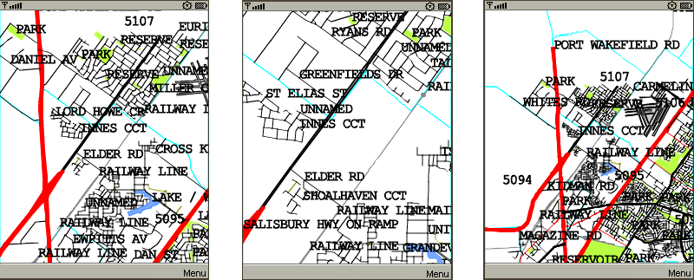
  - Map Pan
LocalMap has two pan methonds, panDirection and panTo. panTo pan the current pan to a given latitude,longtitude, panDirection move the map to some distance relative to current position.
The following example how to pan the map in up,down,left,right directions.

//--------------------------------- PACKAGE ------------------------------------
package biz.guidebee.gis.local.example;

//--------------------------------- IMPORTS ------------------------------------
import java.io.*;
import javax.microedition.midlet.*;
import javax.microedition.lcdui.*;

import biz.guidebee.drawing.*;
import biz.guidebee.geometry.*;
import biz.guidebee.gis.local.*;
import biz.guidebee.gis.geometry.*;

import biz.guidebee.licence.*;

class MapPanCanvas extends Canvas2D implements CommandListener{
public LocalMap map=null;
private Command cmdUp=new Command("Up",Command.ITEM,1);
private Command cmdDown=new Command("Down",Command.ITEM,1);
private Command cmdLeft=new Command("Left",Command.ITEM,1);
private Command cmdRight=new Command("Right",Command.ITEM,1);

MapPanCanvas(Display display) throws InvalidLicenceException{
super(display);

addCommand(cmdUp);
addCommand(cmdDown);
addCommand(cmdLeft);
addCommand(cmdRight);
setCommandListener(this);
}

protected void drawMapImage(){
try{
Graphics2D graphics2D=this.getGraphics();
graphics2D.clear(Color.WHITE);
Image image=map.getMapImage();
graphics2D.drawImage(image,0,0,Graphics.TOP|Graphics.LEFT);
graphics2D.invalidate();
} catch(IOException e){
//ingore
}
}

public void commandAction(Command command, Displayable displayable) {
// for Tool command
if (command == cmdUp) {
map.panDirection(0,-32);
drawMapImage();
}
if (command == cmdDown) {
map.panDirection(0,32);
drawMapImage();
}
if (command == cmdLeft) {
map.panDirection(-32,0);
drawMapImage();
}
if (command == cmdRight) {
map.panDirection(32,0);
drawMapImage();
}
}
}
/**
* This hello world example show the basic of using Guidebee Map Local API.
* <p>
* <hr><b>&copy; Copyright 2008 Guidebee, Inc. All Rights Reserved.</b>
* @version 1.00, 05/03/08
* @author Guidebee, Inc.
*/
public class MapPan extends MapLocalMIDlet {
/**
* The display object associated with the MIDlet.
*/
private Display display;

/**
* The Canvas object.
*/
private MapPanCanvas canvas;

/**
* The graphics object.
*/
private Graphics2D graphics2D;

private LocalMap localMap=null;

public MapPan() throws InvalidLicenceException {
super();
display = Display.getDisplay(this);
canvas = new MapPanCanvas(display);
GeoBounds bounds=new GeoBounds(0,0,canvas.getWidth(),
canvas.getHeight());
localMap=new LocalMap(bounds);
canvas.map=localMap;
graphics2D = canvas.getGraphics();
}

public void startApp() throws MIDletStateChangeException {
display.setCurrent(canvas);
//Clear the canvas with white color.
graphics2D.clear(Color.WHITE);
AffineTransform matrix=new AffineTransform();
graphics2D.setAffineTransform(matrix);

try{
String geoSetFile="/MawsonLakes.pst";
InputStream is=this.getClass().getResourceAsStream(geoSetFile);
if(is!=null){
int fileLength=is.available();
byte []buffer=new byte[fileLength];
is.read(buffer);
ByteArrayInputStream bais=new ByteArrayInputStream(buffer);
DataInputStream reader=new DataInputStream(bais);
GeoSet geoSet=new GeoSet(this,reader);
is.close();

localMap.setGeoSet(geoSet);
localMap.fontEx=FontEx.getSystemFont();
localMap.open();
localMap.mapProjection=LocalMap.MAP_PROJECTION_WGS84;
localMap.setZoom(13);
Image image=localMap.getMapImage();
graphics2D.drawImage(image,0,0,Graphics.TOP|Graphics.LEFT);

}

} catch(Exception e) {
System.out.println(e.getMessage());
}

graphics2D.invalidate();
}

public void pauseApp() {
}

public void destroyApp(boolean unconditional)
throws MIDletStateChangeException {
canvas.flush();
canvas = null;
System.gc();
}
}

  - Zoom Layering
Sometimes you want a map layer to display only at certain zoom levels. Zoom layering allows you to view a map layer when the map's zoom level falls within a preset distance. You can set a different zoom layering level for each layer.
For example, if your map includes a street map layer, you may find that the streets become illegible when the user zooms out too far.
Using zoom layering, you might set up your map so that LocalMap automatically hides the streets whenever the user zooms out to show an area larger than 5 miles.
localMap.mapUnit=LocalMap.MAPUNIT_MILE; //map unit can be mile or km.
//Railway station
localMap.getMapLayer(0).zoomLevel=true;
localMap.getMapLayer(0).zoomMin=0; //Sets mininum zoom to 0 miles
localMap.getMapLayer(0).zoomMax=5; //Sets maximum zoom to 5 miles.

Once you set zoom layering for a layer, when you zoom within the minimum and maximum zoom levels, the layer will display on the map, otherwise this layer is invisible.
The range used to check the zoomMin and zoomMax is the screen width in MapUnit.

- Local Map query
LocalMap also provides methods let application to query tabular data associate with each map object and spatial query for a given region.
  - General query In Data Table
Each geographical map object can also assocate some tabular data with it. For example, in the “Railway station” layer, it has following tabular data record for each “Railway station” in the map.
MapLayer has a property “dataTable”, which is used to stand for such tabular table.
The following example finds “CAVAN STN” railway station, and moves the map to center at the railway station.

//--------------------------------- PACKAGE ------------------------------------
package biz.guidebee.gis.local.example;

//--------------------------------- IMPORTS ------------------------------------
import java.io.*;
import javax.microedition.midlet.*;
import javax.microedition.lcdui.*;

import biz.guidebee.drawing.*;
import biz.guidebee.geometry.*;
import biz.guidebee.gis.*;
import biz.guidebee.gis.local.*;
import biz.guidebee.gis.geometry.*;

import biz.guidebee.licence.*;
import java.util.*;

public class FindAddress extends MapLocalMIDlet {
/**
* The display object associated with the MIDlet.
*/
private Display display;

/**
* The Canvas object.
*/
private Canvas2D canvas;

/**
* The graphics object.
*/
private Graphics2D graphics2D;

public FindAddress() throws InvalidLicenceException {

super();
display = Display.getDisplay(this);
canvas = new Canvas2D(display);
graphics2D = canvas.getGraphics();
}

public void startApp() throws MIDletStateChangeException {
display.setCurrent(canvas);
//Clear the canvas with white color.
graphics2D.clear(Color.WHITE);
AffineTransform matrix=new AffineTransform();
graphics2D.setAffineTransform(matrix);
LocalMap localMap=null;
try{
String geoSetFile="/MawsonLakes.pst";
InputStream is=this.getClass().getResourceAsStream(geoSetFile);
if(is!=null){
int fileLength=is.available();
byte []buffer=new byte[fileLength];
is.read(buffer);
ByteArrayInputStream bais=new ByteArrayInputStream(buffer);
DataInputStream reader=new DataInputStream(bais);
GeoSet geoSet=new GeoSet(this,reader);
is.close();
GeoBounds bounds=new GeoBounds(0,0,canvas.getWidth(),canvas.getHeight());
localMap=new LocalMap(bounds);
localMap.setGeoSet(geoSet);
localMap.fontEx=FontEx.getSystemFont();
localMap.open();
localMap.mapProjection=LocalMap.MAP_PROJECTION_WGS84;
//Get the railwayMaplayer
MapLayer railwayLayer=localMap.getMapLayer(0);

FindConditions findConditions=new FindConditions();
findConditions.fields=railwayLayer.dataTable.fields;
findConditions.addCondition("Name","CAVAN");
Hashtable findResult=railwayLayer.search(findConditions);
Enumeration keys=findResult.keys();
Integer mapInfoID=null;
String nameOfRailwayStation;
boolean bFind=false;
while(keys.hasMoreElements()){
mapInfoID=(Integer)keys.nextElement();
nameOfRailwayStation=(String)findResult.get(mapInfoID);
System.out.println(mapInfoID.toString() + ":" +nameOfRailwayStation);
bFind=true;
}
if(bFind){
MapPoint mapPoint
=(MapPoint)railwayLayer.getMapObjectByID(mapInfoID.intValue());
localMap.panTo(mapPoint.point);
}

localMap.setZoom(16);
Image image=localMap.getMapImage();
graphics2D.drawImage(image,0,0,Graphics.TOP|Graphics.LEFT);
localMap.close();
}

} catch(Exception e) {
System.out.println(e.getMessage());
}

graphics2D.invalidate();
}

public void pauseApp() {
}

public void destroyApp(boolean unconditional)
throws MIDletStateChangeException {
canvas.flush();
canvas = null;
System.gc();
}
}

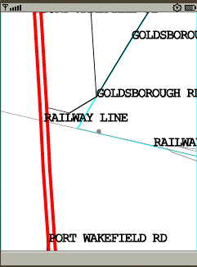
MapLayer’s search(FindConditions findConditions) ,return a hashtable, the key for the hashtable is the MapInfoID of the map Object, the value is the matched string ,in this case ,is the name of the railway station.
For a given MapInfoID, MapLayer also allow you to query all the fields for that record.
It has a method
public DataRowValue getDataRowValueByID(int mapInfoID)
which returns a DataRowValue ,then you can access each field with this object.
FindConditions defines the matching condition, i.e, which field match which string. Only Field with data type as String can be used as a FindCondition, several find condtion can be “ORed” to make a combined FindConditions.

  - Spatial query in Geodatabase
LocalMap and MapLayer both provide search (GeoLatLngBounds rectGeo) to query all map objects in given sptial region.
LocalMap return a Hashtable array, each element in the array is the search results for a map layer.
The key for the hasttable is also the MapInfo ID, the value is the minimum boundary rectangle (MBR) of that map Object.
Actually LocalMap.getMapImage() calles search(GeoLatLngBounds rectGeo) to query all map object within the range of screen and then draw them in the image object.

If you want to render the map yourself, there’s a way to do so, by drawing the map image yourself, you can make control of every map object you want draw, its color, fontsize, font type etc.
First call one of the search with given spatial region (screen size) and the call graphics drawing method to draw each map object. For your convenience, Guidebee Local Map API provides a class SutherlandHodgman, which provide clipping algorithm; you can use it to clip region/ pline before you drawing on the screen.
- Other features
  - Drawing quality
LocalMap can be drawing either with a high quality or a lower quality, when drawing with high quality, it uses Graphcs2D API, when drawing with lower quality, it uses javax.microedition.lcdui.Graphics to draw the map image.
All the above examples draw with a high quality.
The following example draw the same map with a lower quality ,but it could be faster when drawing.
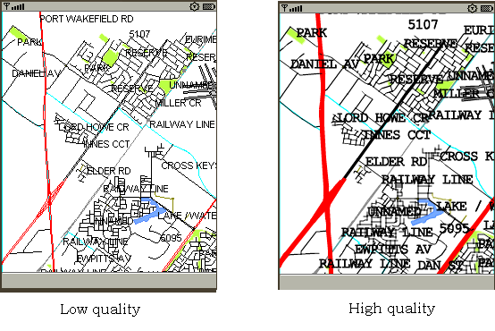

  - Access map file from Memory card
In most cases, the whole map file won’t fit in the main memory because it’s big. Guidebee Local Map API support access map file from memory card, the requirement is that your device support JSR75 FileConnection API, and the the inputStream for JSR75 support mark() methods because Local Map API requires random access to the map file.
Access map file from memory card has no much difference with access map file from resources, only difference is when create GeoSet or MapLayer, gives the path to memory card.
The following examples display city of Nanjing, China . The map data of Nanjing is stored in memeory card
//memory card/map/nanjing
And font in
//memory card/fonts
In this example , Chinese character need to shown for the name of road, poi etc. we use font of Songti also stored in the memory card.

package biz.guidebee.gis.local.example;

import javax.microedition.midlet.*;
import javax.microedition.lcdui.*;

import biz.guidebee.drawing.*;
import biz.guidebee.geometry.*;
import biz.guidebee.gis.local.*;
import biz.guidebee.gis.geometry.*;

import biz.guidebee.licence.*;
import javax.microedition.io.Connector;
import javax.microedition.io.file.FileConnection;

public class AccessMemoryCard extends MapLocalMIDlet {
/**
* The display object associated with the MIDlet.
*/
private Display display;

/**
* The Canvas object.
*/
private Canvas2D canvas;

/**
* The graphics object.
*/
private Graphics2D graphics2D;

public AccessMemoryCard() throws InvalidLicenceException {

super();
display = Display.getDisplay(this);
canvas = new Canvas2D(display);
graphics2D = canvas.getGraphics();
}

public void startApp() throws MIDletStateChangeException {
display.setCurrent(canvas);
//Clear the canvas with white color.
graphics2D.clear(Color.WHITE);
AffineTransform matrix=new AffineTransform();
graphics2D.setAffineTransform(matrix);
LocalMap localMap=null;
try{
String fontName="file:///fonts/songti.fon";
FileConnection fconn = (FileConnection)Connector.open(fontName);
FontEx fontEx=new FontEx(fconn.openInputStream());
String geoSetFile="file:///map/nanjing/nanjing.pst";
GeoSet geoSet=new GeoSet(geoSetFile);
GeoBounds bounds=new GeoBounds(0,0,canvas.getWidth(),
canvas.getHeight());
localMap=new LocalMap(bounds);
localMap.setGeoSet(geoSet);
localMap.fontEx=fontEx;
localMap.open();
localMap.mapProjection=LocalMap.MAP_PROJECTION_WGS84;
localMap.setZoom(15);
GeoLatLng latLng=new GeoLatLng(32.067459,118.811569);
localMap.panTo(latLng);

//Node layer
MapLayer nodeLayer=localMap.getMapLayer(0);
nodeLayer.visible=false;
//POI layer
MapLayer poiLayer=localMap.getMapLayer(1);
poiLayer.fontColor=0x0000FF;//blue
poiLayer.zoomLevel=true;
poiLayer.zoomMin=0;
poiLayer.zoomMax=5; //5 km.
//Landmark layer
MapLayer landmarkLayer=localMap.getMapLayer(2);
landmarkLayer.fontColor=0x0000FF;//blue
landmarkLayer.zoomLevel=true;
landmarkLayer.zoomMin=0;
landmarkLayer.zoomMax=5; //5 km.
//Admin Landmakr layer
MapLayer adminLandmarkLayer=localMap.getMapLayer(3);
adminLandmarkLayer.fontColor=0x0000FF;//blue
adminLandmarkLayer.zoomLevel=true;
adminLandmarkLayer.zoomMin=0;
adminLandmarkLayer.zoomMax=5; //5 km.
//Road layer
MapLayer roadLayer=localMap.getMapLayer(4);
roadLayer.fontColor=0xFF0000;//red
roadLayer.zoomLevel=true;
roadLayer.zoomMin=0;
roadLayer.zoomMax=10; //10 km.
//Railway layer
MapLayer railwayLayer=localMap.getMapLayer(5);
railwayLayer.fontColor=0xFF0000;//red
railwayLayer.zoomLevel=true;
railwayLayer.zoomMin=0;
railwayLayer.zoomMax=10; //10 km.
//Landuse layer
MapLayer landuseLayer=localMap.getMapLayer(6);
landuseLayer.fontColor=0x00FF00;//blue
landuseLayer.zoomLevel=true;
landuseLayer.zoomMin=0;
landuseLayer.zoomMax=20; //20 km.
//Block Layer
MapLayer blockLayer=localMap.getMapLayer(7);
blockLayer.fontColor=0x00FF00;//blue
blockLayer.zoomLevel=true;
blockLayer.zoomMin=0;
blockLayer.zoomMax=20; //20 km.
//Admin layer
MapLayer adminAreaLayer=localMap.getMapLayer(8);

Image image=localMap.getMapImage();
graphics2D.drawImage(image,0,0,Graphics.TOP|Graphics.LEFT);
localMap.close();
fconn.close();

} catch(Exception e) {
System.out.println(e.getMessage());
}

graphics2D.invalidate();
}

public void pauseApp() {
}

public void destroyApp(boolean unconditional)
throws MIDletStateChangeException {
canvas.flush();
canvas = null;
System.gc();
}
}

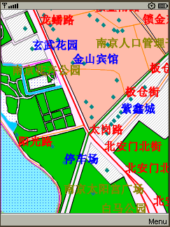

- Licence
Guidebee Map (Local) API provides classes to access map services from Yahoo, Microsoft etc. before using their map service, please read their User Agreement. Your violation of their TOU is at your own risk.

Licence from Guidebee Biz. Includes two parts:
- The licence key
Gives the product name “MapLocal” and licence keys, six long integers. To correctly use this library, you need to call LicenceManager to add correctly licence to the LicenceManager.
- And the licence file.
The file name is guidebee.lic, which need to put in the root directory of the resource with the MIDlet jar file.
If develops with Wireless tool kit, the licence file needs to put in the res directory. If develops with Netbean, the licence file needs to put in the src directory.

package biz.guidebee.gis.example;

//--------------------------------- IMPORTS ------------------------------------
import javax.microedition.midlet.*;
import javax.microedition.lcdui.*;
import biz.guidebee.licence.*;

class DummyCanvas extends Canvas{
protected void paint(Graphics g){

}
}
//[------------------------------ MAIN CLASS ----------------------------------]
////////////////////////////////////////////////////////////////////////////////
//--------------------------------- REVISIONS ----------------------------------
// Date Name Tracking # Description
// -------- ------------------- ------------- --------------------------
// 09DEC2007 James Shen Initial Creation
////////////////////////////////////////////////////////////////////////////////
/**
* Sample discription.
* <p>
* <hr><b>&copy; Copyright 2007 Guidebee, Inc. All Rights Reserved.</b>
* @version 1.00, 09/12/07
* @author Guidebee, Inc.
*/
public abstract class MapLocalMIDlet extends MIDlet {

protected int mapHeight=0;

protected int mapWidth=0;
/** Creates a new instance of GISMIDlet */
public MapLocalMIDlet() throws InvalidLicenceException {

LicenceManager licenceManager=LicenceManager.getInstance(this);
long keysGraphics2D[]= {-0x48523e11722cf1e0L,-0x7eab332624e15dacL,0x5e68724c65503e52L,0x637ab6e46b72a114L,0x6af10ba17aae79f6L,0x5828d65d6df1850L};
licenceManager.addLicence("Graphics2D",keysGraphics2D);
long keysMapLocal[]= {-0x6b03c8f6860c23d9L,-0x379e22cc6ca718acL,
0x565383647869c20bL,-0x60a0f05630a680aL,-0x6075fd6b840d6c9dL,
-0xf1b48b189e5ab2aL};
licenceManager.addLicence("MapLocal",keysMapLocal);
DummyCanvas canvas=new DummyCanvas();
mapHeight=canvas.getHeight();
mapWidth=canvas.getWidth();

}

}

LicenceManager locates in package biz.guidebee.licence which is not part of Graphcis 2D API.
It has two static methods.

public static LicenceManager getInstance(MIDlet midlet)
public void addLicence(String appName,long[]keys)
throws InvalidLicenceException
getInstance returns an instance of LicenceManager ,it takes the MIDlet instance which uses the libraray as the input parameter.

addLicence add licence to the LicenceManager, it takes the appName ,in this case “MapLocal” and the licence key.

If the licence key is invalid ,missing or the guidebee.lic is invalid,missing or placed in wrong place, InvalidLicenceException will be thrown, or you forget to add the code to add the licence to the LicenceManager
In this case, you cannot use most of the core API of Map API library.
Generally speaking, you don’t need licence for Graphics2D library to use Map (Local) API. But if you want to use some functionality provided by Graphics2D ,you need both licences.

